

|  |  |
| --- | --- |
| **ML Consultany** | **Our Services: 1,** **Audit’s in organizations related to QEHS. 2. Certification of company’s related to ISO OHSMS, ISO EMS & ISO QMS & IMS. 3. Preparing ERP (Emergency Response Plan) & Conducting Mock Drills as per standards related to EHS. 4, Documentation preparation support related to QEHS. 5, Fire Equipment Installations and Fire License as per Government norms. 6, PPE’s Supply related to any Industry. 7, Trainings related to EHS (Online & Classroom). 8, Preparing EHS Training Modules. 9, Supporting in QEHS Studies. 10, Supporting in investigations related to any type of Incidents.**  **Chief Consultant: -Ghanta Bharat. Mobile No: 99498 45759, 77269 32023 Email ID: bharat.ghanta@Gmail.com;ghantabharat@yahoo.com** |

***Audit’s in organizations related to QEHS.***

***What is called as Auditing:***

​

Auditing is defined as the on-site verification activity, such as inspection or examination, of a process or quality system, to ensure compliance to requirements. An audit can apply to an entire organization or might be specific to a function, process, or production step.

​

ML Consultancy has been providing 3rd Party Independent QEHS audits to all industries since her inception.

​

Our pool of auditors is fully committed in adding value to your esteemed organization QEHS System by providing detailed and informative audit reports based on the following list of audit services:

​

* Mandatory S & HMS Audits
* Construction Worksite
* Metalworking Industry
* Shipyard
* Oil Refinery
* Petrochemical Plant
* Semiconductor Wafer Fabrication Plant
* Chemical Manufacturing Plant
* Pharmaceutical Plant
* Bulk Storage Terminal
* Internal ISO 9001 / ISO 14001 / ISO 45001
* Safety Audit for the Handling of Hazardous Substances

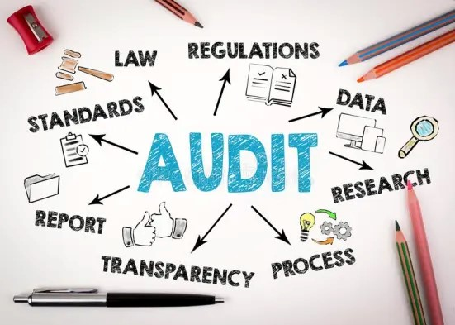

***Types of Audits: -***

1, IMS Audit

2, Safety Audit

3, Environment Audit

4, Health & Safety Audit

5, Survivalence Audit

***Certification of company’s related to ISO OHSMS, ISO EMS & ISO QMS & IMS.***

What is meant by Certification? -​

Certification is the formal attestation or confirmation of certain characteristics of an object, person, or organization. This confirmation is often, but not always, provided by some form of external review, education, assessment, or audit. Accreditation is a specific organization's process of certification. ​

MLC Certification was founded with the simple aim of providing a certification service which goes beyond simply ticking the boxes. We wanted to provide a service which went beyond the grey, unemotional check-list approach to auditing and inspection which has typified the industry for far too long. As a result, we have constantly endeavored, and will continue to strive to introduce new, cutting edge and innovative approaches to meet the needs of our clients. ​

Journey to Certification​

Detailed Proposal: -

After a brief discussion with a member of our business development team, when you are ready to proceed, we will provide you with an individually tailored proposal, covering the investment required to obtain your ISO certification.

Steps to Certification: -

Obtain a full copy of the relevant ISO Standard documentation and review the requirements. Assemble your team, review our training course and define your strategy. Develop and implement your management system (policies, procedures and controls). You are now ready to start the assessment process for your management system.

Pre-Assessment: -

Pre-­assessment is an early opportunity to review your management system against the requirements of the relevant ISO standards (s), Your assessor will conduct a gap-­analysis and provide you with a full report of any areas to address before the formal assessment begins. After each stage, the assessor with prepare and deliver a comprehensive written assessment report detailing the findings of the assessment.

Stage One Assessment

This initial assessment determines if the mandatory requirements of the standard are being met and if the management system is capable of proceeding to stage two. Non-­conformities identified by the assessor will need to be addressed by your organization. At the end of your stage one assessment, all areas should be compliant with requirements of the relevant ISO standard(s) and allow progression to stage two.

Stage Two Assessment

The stage two assessment determines the effectiveness of your management system, and seeks to confirm that your management system controls have been implemented and is fully operational. If your assessor is satisfied that your organization is fully compliant with the relevant ISO standard(s), they will recommend your organization for certification.

Certification Decision

At this point in the process the assessor reviews any corrective actions taken to address findings raised in stage one and two. On successful completion of stages one and two, your assessor will make a recommendation for certification. The Certification Manager will review your file to ensure that the recommendation is made in an impartial, fair and competent manner.

Certification Presentation

Once ISO certification is achieved, your organization will be issued with a Certification certificate and frame. You will also be provided with relevant logos (stickers and electronic versions) and an online digitally-­signed version of your certificate.

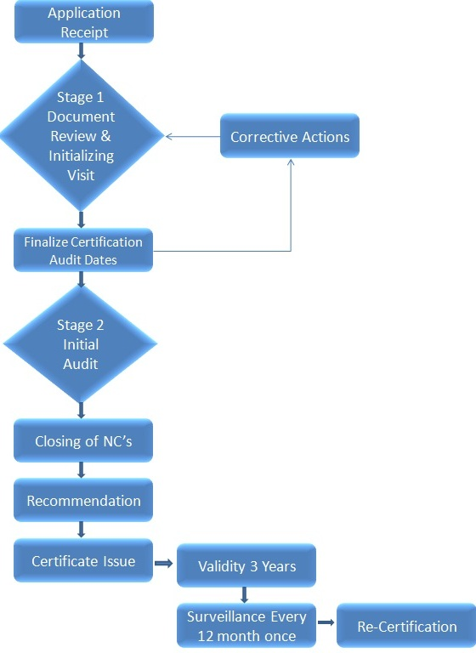

***Preparing ERP (Emergency Response Plan) & Conducting Mock Drills as per standards related to EHS.***

What Is an Emergency Response Plan? An emergency response plan is a document that lays out the series of steps your organization will take during a critical event, such as a fire or active shooter threat, to ensure employees' safety and minimize the impact on emergency operations.

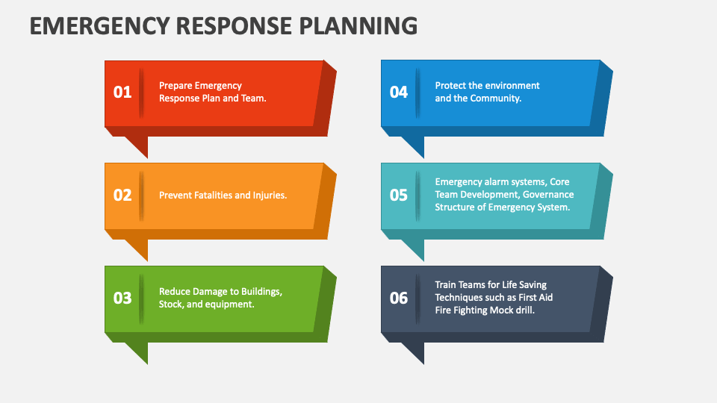

***Documentation preparation support related to QEHS.***

***QEHS Documentation:***

​

The EHS document templates are required for any Organization for getting certified in ISO 14001:2015, ISO 9001:2015 and 45001:2018 compliance. As each business is different, additional QEHS documents or revisions would be required to meet your organization’s specific needs, requirements, context, risk profile, etc. ​​If after reading through all of these documents, you feel like you need a consulting partner to help you develop your new QEHS documents.

***Mandatory Documents Required for OHSMS (Occupational Health & Safety Management System) Certification:***

​

* OH & S Manual
* OH&S policy
* Organization chart
* Identifying interested parties such as neighbors, regulatory bodies, NGO’s and employees
* Risk matrix
* OH&S objectives and plans
* ERP Plan & Mock drill reports
* HIRA
* Legal Register
* Skill matrix, Training records
* Communication evidence
* ERP Plan & Mock drill reports
* Check lists of equipment's, third party certificates, calibration certificates, etc.
* PM Schedule, Calibration certificates
* Legal Register
* Audit schedule
* Audit report
* Minutes of Management Review
* Incidents Register
* Investigation reports of incidents
* Action plans
* Procedure for determining context of the organization and interested parties
* Procedure for identification and evaluation of environmental aspects and risks
* Competence, training and awareness procedure
* Procedure for communication
* Procedure for document and record control
* Procedure for internal audit
* Procedure for management review
* Procedure for management of nonconformities and corrective actions.

***Mandatory Documents Required for EMS (Environment Management System) Certification:***

***​***

* EHS Manual
* Environmental policy
* Identifying interested parties such as regulatory bodies, neighbors, employees, NGO’s
* Risk matrix
* Aspect-Impact register
* Significant environmental aspects
* Environmental objectives and plans
* OCP
* ERT Team, ERP Plan & Mock drill reports
* Legal register
* Skill matrix, Training records
* Communication evidence such as notice boards, emails, any bulletin
* Checklists, compliance registers, third party certification, calibration
* Audit programme
* Audit report
* Minutes of Management review
* Action plans
* Procedure for determining context of the organization and interested parties
* Procedure for identification and evaluation of environmental aspects and risks
* Competence, training and awareness procedure
* Procedure for communication
* Procedure for document and record control
* Procedure for internal audit
* Procedure for management review
* Procedure for management of nonconformities and corrective actions.

***Mandatory Documents Required for QMS (Quality Management System) Certification:***

* The organization's quality policy and quality objectives.
* Quality manual.
* Procedures, instructions, and records.
* Data management.
* Internal processes.
* Customer satisfaction from product quality.
* Improvement opportunities.
* Quality analysis.

***Fire Equipment Installations and Fire License as per Government norms.***

***Welcome to ML Consultancy Fire Systems Wing:***

​

If your business is on fire-risk, you need to check it and search for the best fire protection solutions to ensure the safety of your business. MLC Fire Systems feel privileged to introduce ourselves as the fire safety solution company providing assistance through our valuable products and services.

Protect yourself from the risk of fire through MLC Fire Systems:

​

One of the experienced fire protection & fire protection solution provider in India. Manufacture, export and marketing of the firefighting equipment in India. Companies which deal with various types of fire protection measures.   
  
The company commenced operations in the year 2007., the company corporate office situated in Hyderabad. MLC Fire Systems operates all across the India with a motto to promote a fire safe atmosphere. Our expert team includes well qualified technical professionals, management professionals, and trained workers in fire and safety field.  
  
We deal with the products according to the need of the customers. Our approach to doing business is customer-centered. Customer satisfaction is of at most importance for us. Our fire safety products range is available for all types of purposes such as household purposes, small businesses purposes, commercial purposes as well as industrial purposes. We ensure the best quality of our wide-ranging products so that not even a small harm can occur at any point in time.  
  
Our team of experts are always ready to provide best support to our customers. At MLC Fire Systems, people not only get the most eligible product for their requirement, but they also receive enormous services related to the training and maintenance of the product. We have completely indulged ourselves in the process of advancing and protecting environment.   
  
Well known fact to everyone that “Precaution is better than cure”. Fire protection equipment's are those precautions that if taken can avoid big mis-happenings.

​

***SERVICES:***

​

***Get the benefit of best services through MLC Fire Systems.***

​

A company is known for its quality services that it provides to the customers. MLC Fire Systems is also known for its type and quality of services. We in coordination with our team members, aim to provide best quality services to our customers in the field of Fire and Safety solutions. Our quality services include:    
   
Checking and maintenance of the product: Our responsibility is not finished after handing over the products to our customers. The main responsibility starts after it. Fire safety equipment is not often used. They are used only at the time of adverse situations. Thus, it becomes very important to properly check the equipment's and products after installation regularly. The maintenance of the products depends on the type of agreement that a customer does at the time of purchasing the equipment's.  
   
Training related to fire and safety: We not only manufacture products for fire safety. We also provide several training's for this purpose. Our training's include training related to evacuation, training related to the use of different fire safety products, training related to different types of fires and some basic tips related to fire fighting.

​

***Explore more about fire safety products provided by MLC Fire Systems.***

​

MLC Fire Systems team provide exceptional quality and variety of products for fire safety measures. These products have their own composition according to their usage. Different types of products are there for different usages. Fire security systems are a necessity at all the public places such as restaurants, hotels, shops, hospitals, schools, colleges, theaters, fuel pumps, factories, industries and many more.   
  
We provide a wide range of products to ensure fire safety at all these places. Our products include Fire Extinguishers, Hydrants, Fire suppression systems, Fireproof helmets, Fireproof suit and Fireproof gloves, Fire alarms systems and many more. If we go into more details about the products, we can find there are different types of fire extinguishers, fire suppression systems as well as hydrants available for different purposes.   
  
To ensure safety from the fire at schools, theaters, and shops, we should generally prefer water fire extinguishers and fire hydrant systems. To ensure security in heavy industries and fuel pumps where the probability of catching fire is highest, hydrant and foam fire extinguishers can be used. Fire detection alarms preferred at these places.

​

​

Formed in 2007 in association with Shield Care, Is one of India’s leading Fire Protection Companies. With over three decades of expertise, MLC Fire Systems provides total custom designed solutions in fire detection, fire suppression and fire protection systems for Industrial requirements.   
  
We, at MLC Fire Systems, are a dedicated group and have adequate manpower resources headed by a team of professionally qualified and experienced engineers in this field who are capable of designing, procuring and executing large magnitude projects right from concept to commissioning stages. New Fire is unrivalled in its position as a one stop total solution company, with office in Hyderabad.

MLC Fire Systems is driven by its zeal in contributing to the welfare and growth of the nation by preventing the loss of life, property and at the same time enhancing business continuity using emerging technologies and deployment of environmentally friendly extinguishing mechanisms.

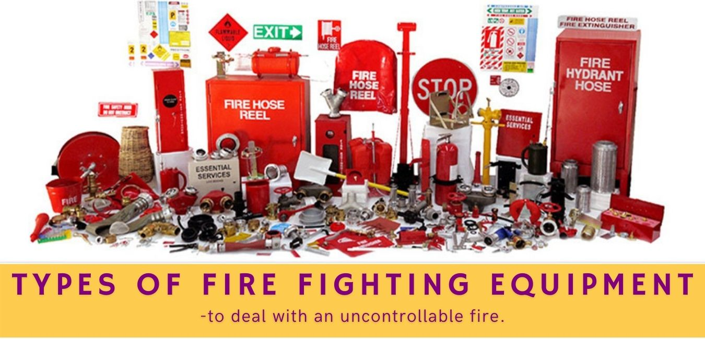

***PPE’s Supply related to any Industry.***

***ML Consultancy PPE Suppliers: -***

​

MLC is the association for safety equipment and technologies – equipment and systems that enable people to work in hazardous environments. MLC has set the standard for personal protective technologies, supporting the interests of its member companies who are united in the goal of protecting the health and safety of people worldwide.

​

MLC is a recognized leader in the development of IS accredited safety equipment standards, in India.  It works with government agencies to consult with policymakers whose decisions affect the industry.  It is a forum for information sharing and industry action, providing market insight and advocating for the use of safety equipment to keep workers safe.

​

***MLC PPE Suppliers Mission:***

​

To be the catalyst that ensures safety products are better, conforming, understandable, and used.

As an MLC member you:

* Have a seat at the table and a voice when standards are being set.
* Have access to world-class training and education that differentiates you from your competitors helping increase your sales and market share.
* Have an advocate in the halls of Government and places of power that impact your business
* Have a platform to engage and collaborate and network with your peers in a spirit of learning, understanding and best practices.

When it comes to safety products, MLC is where it all happens.

***Types of PPE.***

1, COVID-19

2, Above Neck

3, Foot Protection

4, Hand Protection

5, Fall Protection

6, Body Protection

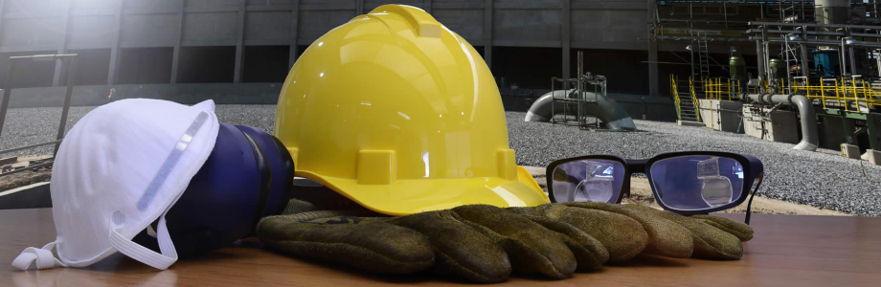

***Trainings related to QEHS (Online & Classroom).***

***ML Consultancy QEHS Training's:***

MLC aim is to offer cutting-edge training and research services to public and private organizations in India. MLC EHS Training's delivers professional training and research programs that are varied in all topics including: - Quality, Environment, Health, Fire & Safety.

​​

We deliver agency-specific training, career development programs, and customized consulting solutions to enrich learning and optimize individual, group and organizational performance.

​

##### ***Key Goals of MLC QEHS Training's:***

​

1. Keep student more interested and interactive  
2. Make learning enthusiastic and natural.  
3. See to be more cooperative with instructor and student  
4. Making concepts applicable in to real time  
5. Flexible time slots for students  
6. Attend through the Phone or PC

​

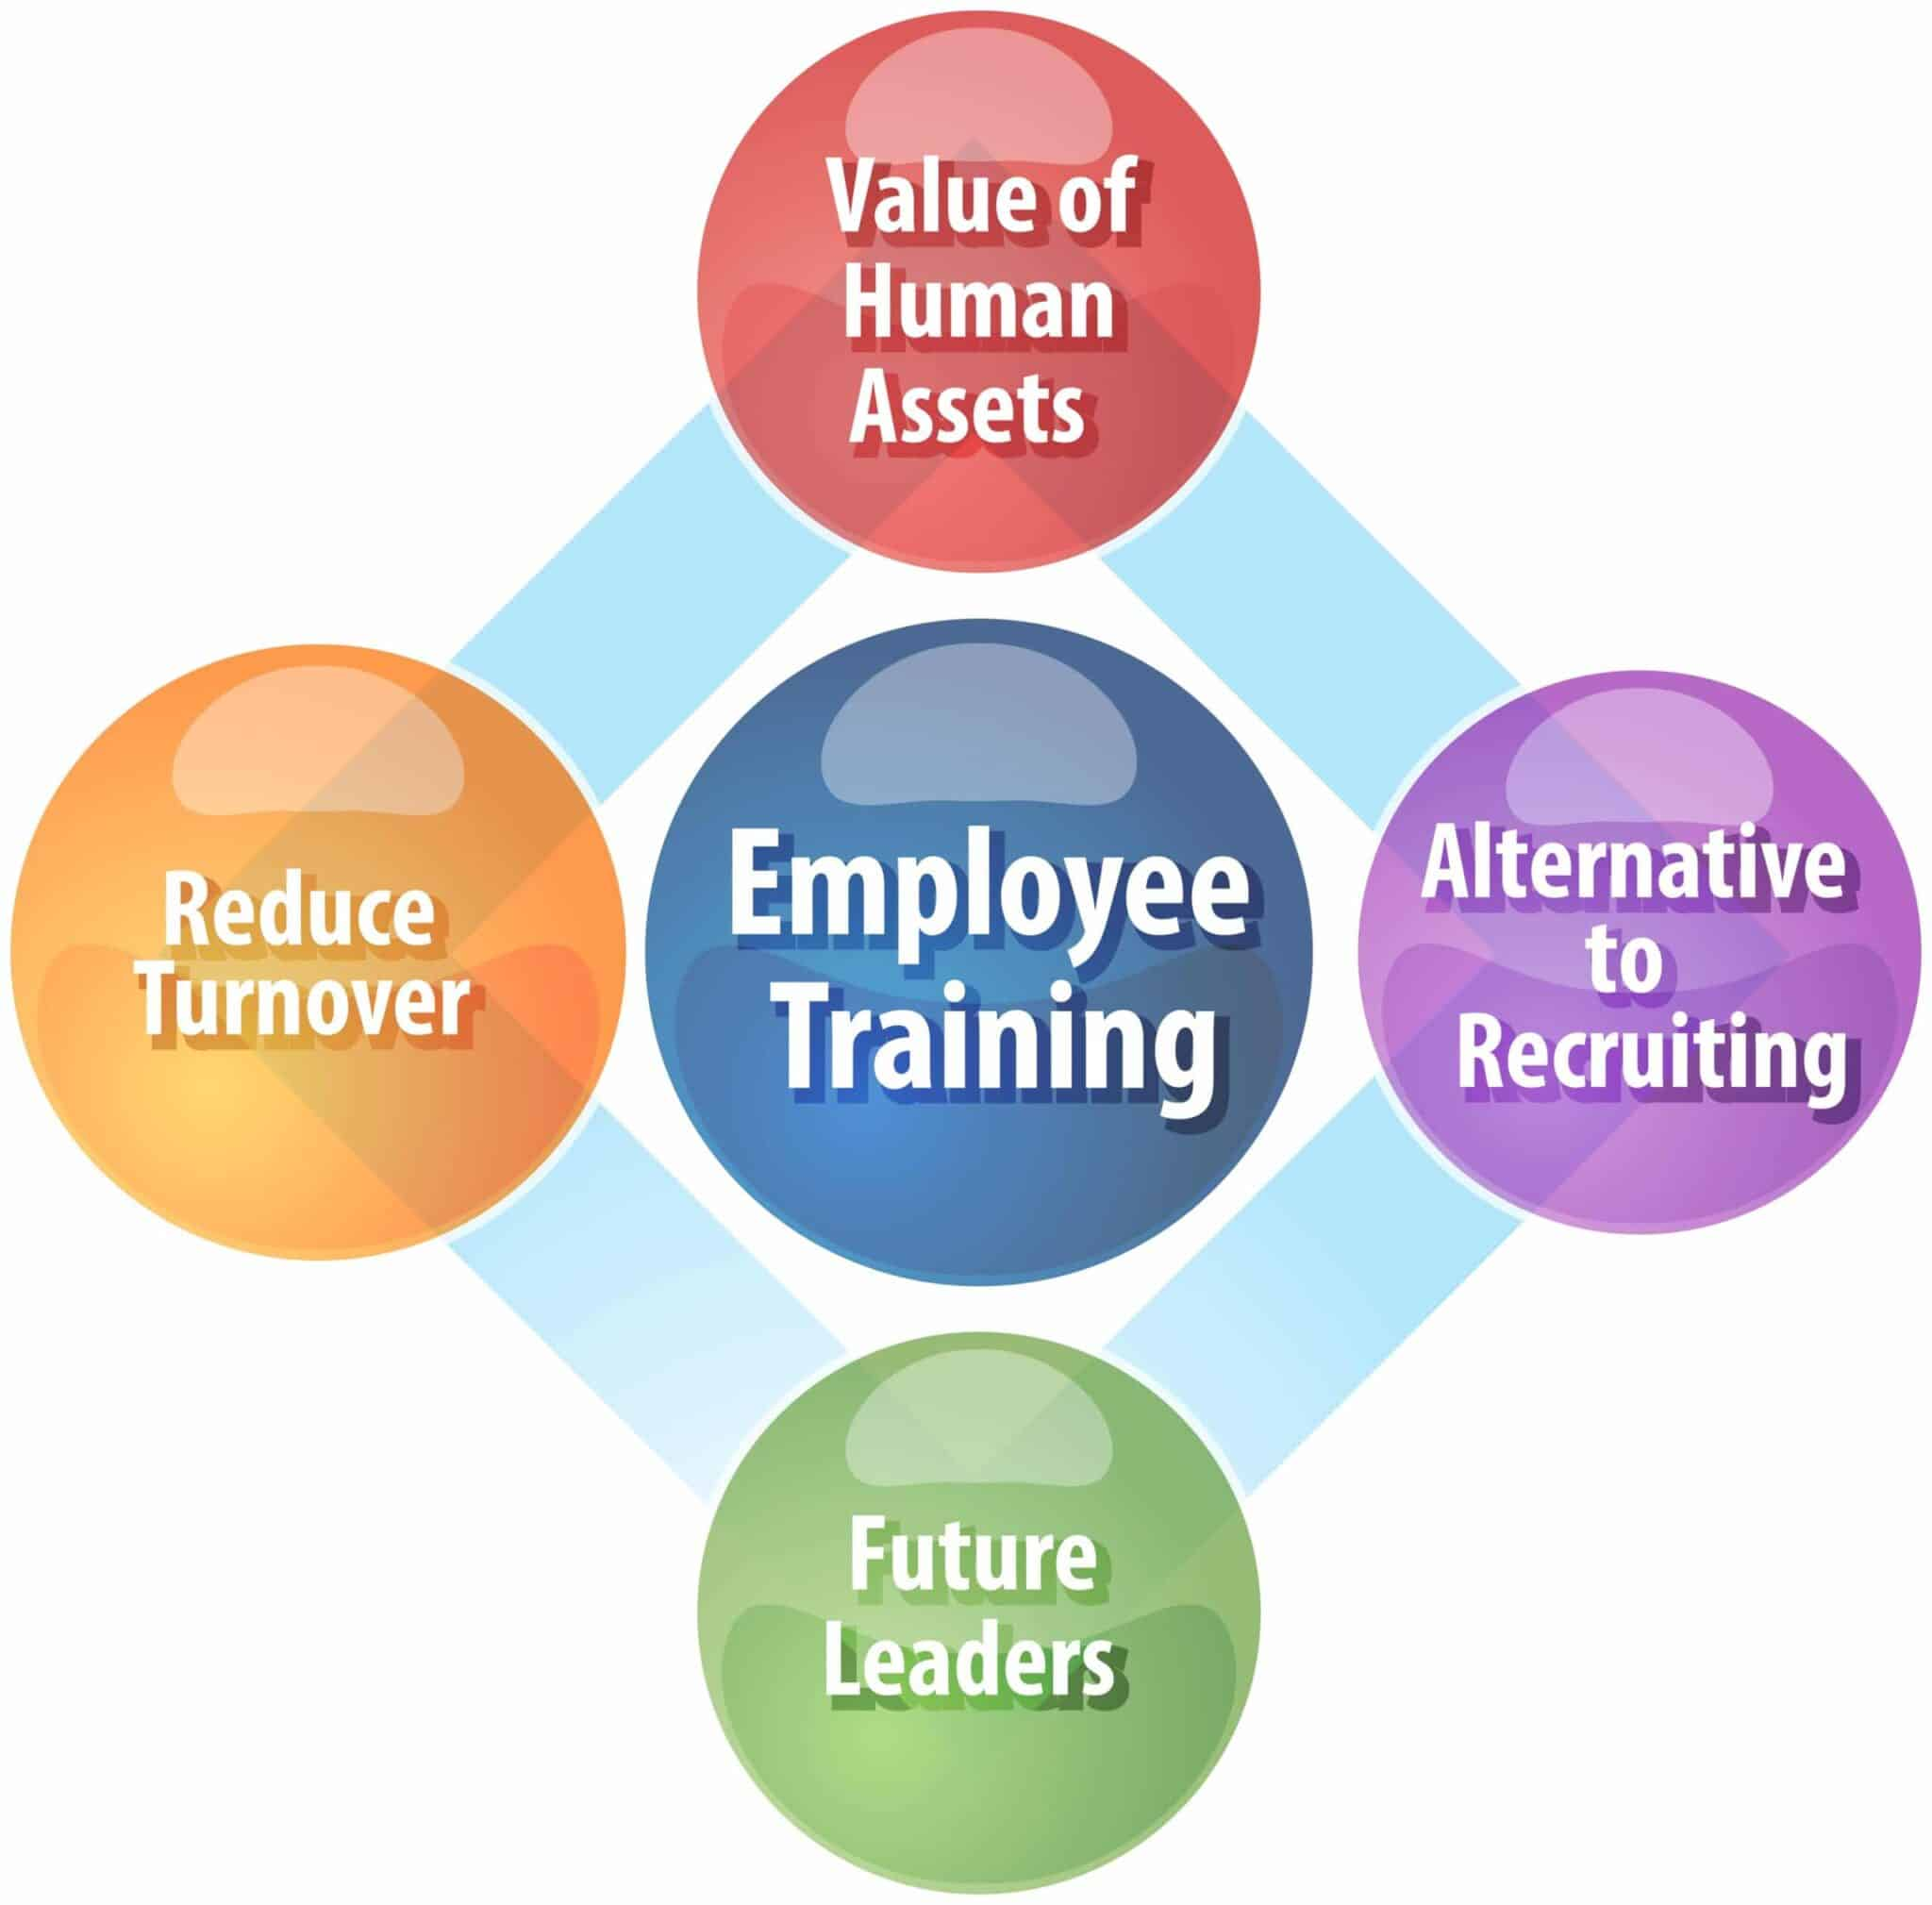

***Preparing QEHS Training Modules.***

**What Is a Training Presentation?**

**A training presentation is a visual tool designed to deliver knowledge in a structured and engaging way in different training contexts.**

It is a format that allows instructors to present training materials that keep the audience responsive and motivated, promoting comprehension and retention.Training presentations are used extensively in educational settings and in staff training. Whether you’re introducing new employees to company policies, teaching students a complex subject, or demonstrating how to use a new software tool, training presentations make learning more effective and engaging.

A good training presentation is a combination of several design and structural elements that ultimately enhance learning effectiveness. Here are some key elements of training presentations:

* **Content**. The core of a training presentation is the content you deliver to your audience. It’s the information you want your trainees to absorb, memorize, and use effectively in the future.
* **Visuals**. Visual elements play a crucial role in training presentations. Besides using slides with text, presenters also include graphics, images, and even [interactive elements](https://www.ispringsolutions.com/blog/10-interactive-presentation-software-grab-and-hold-an-audiences-attention). These visuals help learners better understand and remember the training material.
* **Structure**. Even with top-notch content and amazing visuals, if the presentation structure is not organized logically, the audience will have a hard time understanding it. That’s why a clear outline is needed so the learners can follow the flow of information and build their knowledge during the training session.
* **Practical exercises and assessments**. It’s a good idea to include assessments or quizzes in your training presentations to determine participants’ understanding and measure the effectiveness of the training. As an instructor, you can also integrate real-life cases and scenarios to help trainees put the recently acquired knowledge into practice.

**The Importance of Effective Training Presentations**

In short, an effective training presentation lays the foundation for more profound training experiences. By structuring information logically and using engaging visuals and interactive elements, training presentations improve training and promote efficient retention of knowledge.

An effective training presentation can become a powerful tool for employee training and professional development because it:

* allows the participants to visualize the training content in a logical structure;
* can be adapted to accommodate different learning styles;
* improves the skill development process for both new and seasoned employees;
* provides a tangible resource that trainees can revisit when they want to refresh their knowledge.

**Types of Training Presentations**

Training presentations come in many forms, depending on learning goals, target audiences, and training contexts. Understanding the different types of training presentations can help you choose the format that’s most suitable for achieving your training objectives.

Let’s take a closer look at some common types of training presentations:

**1. Informative Presentation**

Informative presentations are the foundation of knowledge transfer. They are designed to deliver key information, facts, or concepts to the training audience. Informative presentations often rely on an instructor with great presentation skills who leads the session.

Some examples of this type of presentation are:

* Lecture-style presentations
* Product knowledge training
* Safety briefings
* Compliance training

These presentations often include a summary slide that highlights what the trainees should take away from the session.

**2. Skill Development Presentation**

Skill development presentations are all about hands-on learning. They provide trainees with opportunities to gain practical skills or new professional competencies. These presentations typically include:

* Demonstrations
* Guided exercises
* Interactive simulations and role-plays
* Feedback and evaluations

All these elements help participants put theory into practice right away. Skill development presentations can also come in the form of pre-recorded [video presentations](https://www.ispringsolutions.com/blog/how-to-create-a-video-presentation-with-ispring-presenter) that illustrate how the skills work in real life.

A skill development training deck is especially useful in scenarios where participants need to master specific techniques or approaches. To reinforce the knowledge provided in the presentation, you can include workshops, hands-on labs, or training sessions with experts in the training program.

**3. Selling or Persuasion Presentation**

This type of presentation is focused on convincing an audience to take specific actions or make particular decisions. It’s often used in marketing, sales pitches, and business proposals.

These presentations tap into persuasive techniques, storytelling, and compelling visuals on slides to influence the audience’s perceptions and choices. Since their primary goal is to persuade the audience, selling presentations may include data-based projections, testimonies from customers, and more.

**4. Progress and Reporting Presentation**

This type of presentation is essential in organizational and enterprise contexts. It provides updates on:

* Project milestones
* Key performance indicators and metrics
* Employee performance
* Quality assurance
* Market analysis, etc.

Progress presentations often include visuals, charts, and graphs to show updates and results effectively. This type of presentation can be used for training programs in customer service, sales, marketing, and any other performance-driven department.

**5. Decision-Making Presentation**

Decision-making presentations guide trainees through the process of making complex choices and confronting challenging scenarios. They provide ideas and strategies for effective decision-making by encouraging critical thinking and problem-solving skills.

***These presentations can be used for:***

* Leadership development
* Crisis management
* Conflict resolution
* Business strategies, and more.

You can also incorporate them to analyze the viability of launching a new product or decide where to allocate resources within the company; any scenario where trainees need to make a decision that impacts a business is relevant.

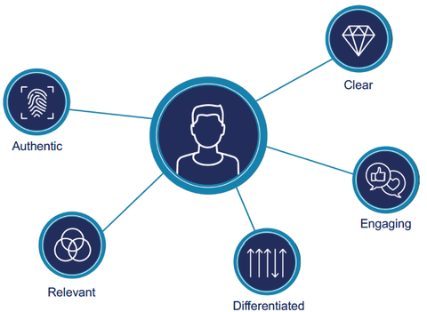

***Supporting in conducting QEHS Studies.***

***Fire Safety***

• Fire & Gas Detection Mapping Study

• Design Adequacy of Fire Protection System

• Business Process Re-Engineering

• Fire Load Calculations

• Fire Risk Assessment /Fire Safety Audit

***Electrical Safety***

• Arc Flash Study

• Lightning Risk Assessment and Design of Lightning Protection System

• Hazardous Area Classification (HAC) – ATEX Study

• Thermography

• Electrical Safety Audit

• E HAZOP

• Inspection of Flameproof Electrical Equipment’s

• Static Electricity Study

• Energy Conservation Audit

• [Electrical Thermography](https://www.sachu.in/electrical_thermography.html)

• [Mechanical Thermography](https://www.sachu.in/mechnical_thermography.html)

• [Building Thermography](https://www.sachu.in/building_thermography.html)

• [Thermovision scanning in Cold Storage, Pharmaceutics](https://www.sachu.in/thermographypharmaceuticalcoldstotage.html)

• [Medical Thermography](https://www.sachu.in/medicalthermography.html)

• [Thermovision Scanning in Transmission lines](https://www.sachu.in/thermovisionscanningtransmissionlines.html)

• [Thermovision Scanning in Cement Boilers, refinery](https://www.sachu.in/thermographycementboilers.html)

• [Thermography in Paper, Pulp, Printing, Packing](https://www.sachu.in/thermographypaperpulppacking.html)

• [Thermography in Hotel, food, beverage, Polymer, fiber, Glass, Milk dairy, Textile](https://www.sachu.in/thermographyhotelbeveragepolymerglassmilkdairytextile.html)

• [Power Quality services and Harmonic study](https://www.sachu.in/powerquality_and_harmonicstudy.html)

• [Power Quality Analysis Audit Services](https://www.sachu.in/powerquality_and_harmonicstudy.html)

• [Harmonic study](https://www.sachu.in/harmonicstudy.html)

• [Energy Audit](https://www.sachu.in/energyaudit.html)

• [Power Audit](https://www.sachu.in/poweraudit.html)

• [Power Factor Audit](https://www.sachu.in/powerfactorystudy.html)

• [Transients Audit](https://www.sachu.in/transients_study.html)

• [Load Flow Analysis](https://www.sachu.in/loadflowanalysis.html)

• [Flicker Study](https://www.sachu.in/flicker_study.html)

• [UPS &Generator Study](https://www.sachu.in/upsstudy.html)

• [Earthing Audit and Insulation Resistance Measurement](https://www.sachu.in/earthingstudy.html)

***Civil Safety***

• Building Structural Stability Study

• Building Risk Assessment – using Non-Destructive Testing

• PHSER Study

• Project Risk Assessment

• Construction Site Safety Audit

***Chemical Safety***

• Chemical Compatibility Study

• Respiratory Fit Testing

• Personal Exposure Study / Workplace Monitoring Study /VOC Study / Chemical Exposure Monitoring Study (IDLH, STEL, TLV)

• Dust Explosion Study

• Dispersion Modeling (Flare, SRV, Dump tanks, Scrubbing Vent Hazards)

• Minimum Ignition Energy Study

• Minimum Ignition Temperature Study

• Bulk Chemical Storage Risk Assessment

***Process Safety***

• PSM Gap Analysis

• Process Safety Management (PSM) Implementation

• Quantitative Risk Assessment (QRA)

• Safety Integrity Level (SIL) Study / LOPA / Functional Safety

• Hazard Identification and Risk Assessment (HIRA) /HARA / HAZID Study

• Hazard & Operability Study (HAZOP)

• Pre-Startup Review

• Business Process Reengineering

• Business Continuity Plan

• Process Hazard Analysis (PHA Study)

• Job Safety Analysis

***Others***

• Human Factor Engineering and Ergonomic Studies

• Statutory Safety Audit/Comprehensive Safety Audit

• Preparation or Vetting of On-Site Emergency Plan

• Preparation or Vetting of Off-Site Emergency Plan

• Pre-Occupancy Audit

• Behavior Based Safety / Safety Culture Survey

• Industrial Hygiene Monitoring Study

• Security Vulnerability Assessment (Security Audit)

• Machinery Risk Assessment

• Logistics Risk Assessment (inside or outside the plant truck movement)

• COPE and Probable Maximum Loss Study (PML) Study

• Inspection behalf of insurance & Brokerage firms (for under writing or value addition or safety improvement) Training

***Supporting in investigations related to any type of Incidents.***

**Why Conduct Incident Investigations?**

Here are some other reasons why an incident investigation might benefit your business and protect you from risks in the future:

* It helps you find the root cause of incidents, which helps you create an action plan to prevent the same and similar incidents from happening again.
* It helps you find gaps in any measures you have already taken to control risks to your business.
* It would also bring out any flaws in your health and safety compliance that you may have not known about, enabling you to fix them.
* In case of workers' compensation or any other insurance claim, insurers might require you to present the findings of your investigation.
* In case of any legal liabilities or claims, an incident investigation would demonstrate that you have been proactive in exploring why an incident may have occurred and in taking steps to prevent future incidents. This shows a positive attitude towards occupational safety and health, which would benefit you in any court hearings.

Apart from these important reasons, conducting a thorough investigation into incidents and even near misses also shows your employees and clients that you're committed to ensuring health and safety in your worksite, increasing employee morale.

**Logistics of an Incident Investigation**

**When and Where Are They Conducted?**

Incident investigations are conducted at the location where the incident has occurred because remote investigations are rarely effective. Make sure to conduct them as soon as possible after it has happened so that any evidence that would help you find the root cause and act on it is not lost. The investigation team should head to the incident scene so that they can collect data that would help them with their work quickly and effectively.

**Who Is Responsible for Conducting the Investigation?**

Ideally, incident investigation teams should be led by people with formal training in such procedures. People with sound knowledge of legal and organizational requirements, basics of occupational health and safety, and the specific work processes related to the particular incident would also be assets to the investigation team. For incidents that have far-reaching consequences, a multi-disciplinary team consisting of both stakeholders and trained personnel may be necessary.

If the incident involves significant injuries or legal consequences, the company's legal team may manage the investigation while taking help from other people throughout the company. For smaller incidents with lower consequences and risks, a single investigator or a two-person team might be enough.

Deciding who would be on the team may also depend on the regulations for your state because some jurisdictions provide guidance such as requiring both management and labor (e.g., a workers' union) to be represented.

**6 Steps of an Incident Investigation Process**

An effective incident investigation involves six main steps, which are described in detail below:

**1. Secure the Scene**

When an incident occurs, the most important thing to do is provide the necessary help in the form of first aid or other medical assistance to any injured workers on site. Only after this should you look at starting your investigation.

The first step in the investigation is to secure the incident scene and preserve any physical evidence using cones or other barriers to protect sensitive areas. If the investigation team has to travel a long distance to reach the scene, on-site management should be instructed to carry out this step. The investigation team should also make sure to follow any safety guidelines required by the site, wearing personal protective equipment (PPE) if necessary.

Once the scene is secured, start documenting the scene by taking photos or videos of the scene, and collecting any perishable physical evidence including CCTV tapes and samples. Depending on the nature of the incident, it might be useful to record what equipment was being used when the incident occurred, weather conditions at the time of the incident, positions and use of machine guards, controls, and safety devices, and other relevant information.

**2. Plan the Investigation**

Once you have secured the scene and recorded immediate information and evidence, it is time to plan the investigation. A systematic investigation plan helps ensure that it is comprehensive and thorough. In this step, you need to decide whom to involve in the investigation, gauge how long it will take, and estimate what resources will be required.

In addition, it is recommended to prepare a kit with all the relevant documents and equipment so that the actual investigation is smooth and efficient. Depending on the circumstances, possible inclusions in the kit could be:

* Cones and barricade markers
* Warning tags or padlocks for really sensitive areas
* PPE
* Measuring tape
* Interview forms
* Investigation forms
* Sample containers

It might be prudent to carry some of these, like the sample containers, cones, etc. to the incident scene when you are going to secure the scene as well.

**3. Collect All Relevant Information**

The next step is to collect all the relevant information related to the incident. Such information is available from various sources, including the people involved, witnesses (whom you should interview), equipment on the scene, and documents such as maintenance logs, inspection reports, and training histories.

Interviewing the people involved and any witnesses to the incident is a crucial step in collecting the information you need, as they can let you know what exactly happened. The information collected through these interviews might include:

* Details about the worker
* Details about any injuries or property damage
* A narrative description of the events that took place (including location of the incident, the sequence of events leading up to the accident or near miss, equipment or objects involved, conditions under which the incident took place, the task being performed when the incident occurred, and other details)
* Information about supervision at the time of the incident
* Causal factors related to the incident

To ensure that the interviews are effective, reduce your employees' possible fears and anxieties and make them feel at ease by assuring them that the purpose of the investigation is to find the cause rather than point blame. Let them know that they can have a labor representative present if they wish.

For the best possible data collection, follow best practices like asking open-ended questions, listening to the interviewees without interrupting, asking clarifying questions and correcting inconsistencies, interviewing the witnesses in the place where the incident occurred to help jog their memories, taking notes and, if possible, recording the interview.

Another way to enrich your data is to ask the workers for their opinions on how they think the incident could have been prevented.

Once you have collected all the required data, it is essential to summarize and document it all by completing an incident investigation form.

**4. Analyze Collected Data to Find the Root Cause**

After the data is collected, it must be analyzed. The goal here is to find the root cause of the incident so that this and similar incidents can be prevented in the future.

Incidents are usually caused by a chain of events rather than a single event, so understanding the sequence of events is crucial to find the root cause. This can be done by performing a root cause analysis, which helps you uncover underlying or systemic issues rather than surface causes of the incident (like human error). A simple but effective technique is the "Five Whys" method, outlined in [**OSHA's root cause analysis fact sheet**](https://www.osha.gov/sites/default/files/publications/OSHA3895.pdf).

It is important to remember here that while finding and rectifying the immediate cause might fix the symptom of the problem (that specific incident) but not the issue itself. Also keep in mind that the root cause is unlikely to be a simple human error. It's likely that there are numerous contributing factors including equipment, environment, organizational management systems, mental or physical abilities of the worker(s) involved, and more. Discovering every contributing factor related to the incident is the only thing that will help you prevent future incidents.

**5. Implement Corrective Actions**

Of course, identifying the root cause of the incident is not enough. To ensure that the incident investigation was useful and not a waste of time, corrective action must be implemented.

Create an action plan to resolve the causes of the incident, both immediate and underlying, assign people to implement the actions, and ensure that the plan is acted upon. Make sure you track the progress of the corrective action plan because if you don't, the actions might never get implemented.

It isn't easy to keep track of such a plan, especially if there are multiple corrective actions with varied people implementing them, or even worse, if there are multiple such incidents to act upon.

**6. Document and Share the Results**

The investigation is finally complete when all issues have been dealt with and the results have been documented and communicated with stakeholders. The documents to be shared include incident investigation reports, fact sheets, alerts, presentations, etc. Meticulous documentation after every incident will eventually form a comprehensive database of risks and incidents that will help deal with any future incidents efficiently.

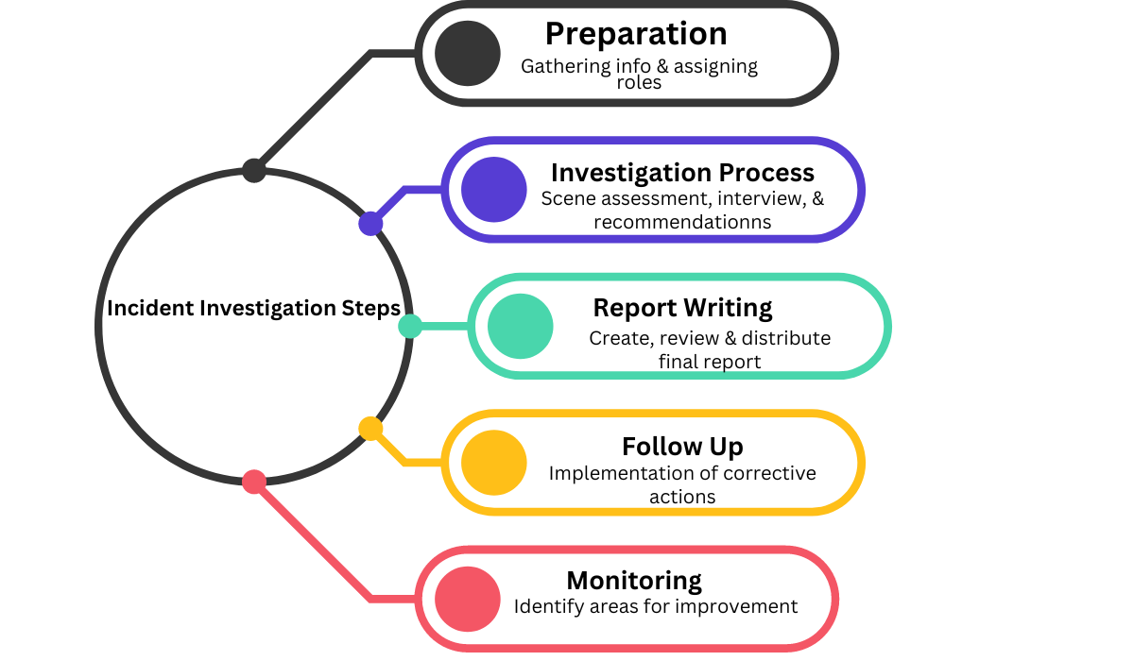Once the report is ready, it is important to get it cross-checked and signed off by any parties involved, such as the supervisor who was on duty when the incident occurred, the witnesses and workers involved in the incident (if applicable), safety officers, and others. After they check the accuracy of the details and sign off on the report, you can share your key findings with management and workers.

***MLC Esteemed clients with Associated Partners***